

Manufacturing Downtime Analysis & Production Optimization System

Neptune Team – DEPI 2026
Diaa Elbanna
Fahd Gomaa
Mohamed Safwat
Mohamed Magdy
Youssef Mohamed

Table of Contents

1. Project Overview 3
2. Objectives 3
3. Dataset & Data Scope 4
4. Data Pipeline & Processing 5
5. System Design & Architecture 6
7. Key Insights & Findings 7
8. Business Recommendations 8
9. Implementation & Deployment 9
10. Testing & Validation 9
11. Project Value & Impact 13

1. Project Overview
Manufacturing downtime represents a critical constraint on production efficiency, directly affecting throughput, operational costs, and revenue generation. Even minor inefficiencies, when scaled across continuous operations, can result in significant financial losses and reduced asset utilization.
This project delivers a data-driven analytical system designed to process and analyze large-scale manufacturing data (1M+ records) to uncover hidden inefficiencies, quantify production losses, and enable proactive decision-making.
The solution integrates data engineering, advanced KPI modeling, and interactive visualization to transform raw operational data into actionable business intelligence through a Power BI dashboard.

2. Objectives
The project addresses key operational and strategic challenges:
- Analyze downtime behavior, frequency, and distribution
- Measure actual production versus target performance
- Identify root causes of scrap, downtime, and inefficiencies
- Evaluate performance across machines, operators, and shifts
- Quantify the financial impact of operational losses
- Enable data-driven optimization of production processes

3. Dataset & Data Scope
Data Source
The dataset is derived from a large-scale industrial dataset (DEPI dataset), enhanced with additional structured tables to support advanced analytics.

Data Volume
The system processes over 1 million records, reflecting real-world manufacturing scale and complexity.

Data Structure
The dataset follows a structured analytical model:
- Fact Tables: Downtime, Maintenance, Quality
- Dimension Tables: Machine, Operator, Product, Shift, Factor

Features & Attributes
The dataset includes more than 26 attributes covering time, production volume, downtime duration, cost, error classification, and operational parameters.
Engineered fields include:
- Downtime Events Count
- Maintenance Flag
- Batch Target Units
- Line Efficiency (%)
- And more…

4. Data Pipeline & Processing
Data Cleaning
A structured preprocessing phase ensured data consistency and reliability:
- Standardized data types (date, time, numeric values)
- Removed duplicates and invalid entries
- Cleaned and normalized categorical variables
- Eliminated unnecessary attributes

Feature Engineering
Additional analytical features were created to enhance performance tracking:
- Unique identifiers for Machines, Operators, Products, and Factors
- Derived metrics for downtime frequency, efficiency, and production analysis

Data Modeling
A Star Schema architecture was implemented:
- Central Fact Table: Downtime Line
- Connected Dimension Tables: Machine, Operator, Product, Shift, Factor
This design enables efficient querying, scalability, and high-performance analytics.

DAX Layer
Custom DAX measures were developed for:
- Maintenance efficiency
- Downtime impact analysis
- Production performance tracking
- Cost and revenue loss evaluation

5. System Design & Architecture
The system follows a layered architecture:
- Data Source Layer → Raw manufacturing data
- Processing Layer → Cleaning, transformation, feature engineering
- Modeling Layer → Structured relational model
- Visualization Layer → Power BI dashboards
This design ensures data integrity, scalability, and future extensibility, including integration with real-time systems such as IoT or SCADA.

6. Dashboard & Visualization
The Power BI dashboard is designed to support both operational monitoring and strategic decision-making.
Key Components
- Production vs Target trends
- Downtime distribution across machines
- Maintenance cost versus downtime duration
- Shift performance comparison
- Revenue versus expected revenue
- Root cause analysis
The dashboard provides interactive filtering and drill-down capabilities, enabling users to move from high-level KPIs to detailed insights.

7. Key Insights & Findings
Operational Performance Gaps
- Production: 36M units vs 39M target → ~3M unit gap
- Scrap: 17M units indicating significant quality issues
- Downtime: 6.58% negatively impacting output

Workforce Insights
- Senior operators contribute 43.6% of total errors
- Approximately 2 million minutes lost due to human inefficiencies
- Noticeable variability in performance across operators

Shift Performance
- Day shift: highest production but also highest losses (~$1.15M)
- Night shift: lowest productivity

Financial Impact
- Actual revenue: 654.3M vs 708.9M target → ~55M loss
- Orange product line contributes the highest revenue loss

Root Cause Analysis
- 21.3% of issues linked to operator errors
- 78.7% attributed to technical and external factors (machines, materials, processes)

8. Business Recommendations
Operations & Maintenance
- Improve machine reliability to reduce unplanned downtime
- Implement preventive maintenance strategies to lower downtime rates
- Strengthening quality control processes to reduce scrap

Workforce Optimization
- Provide targeted training for senior operators
- Address high-error individuals through performance improvement plans
- Standardized operational procedures

Shift Optimization
- Balance workload across shifts
- Increase supervision during high-loss periods (day shift)
- Improve efficiency of night shift operations

Strategic Business Actions
- Prioritize high-impact product lines (e.g., Orange product)
- Implement Overall Equipment Effectiveness (OEE) metrics
- Align production planning with revenue targets

9. Implementation & Deployment
Tools & Technologies
- Power BI for visualization
- DAX for analytical calculations
- Excel / CSV for preprocessing
- Star Schema for data modeling

Deployment
The solution is deployed on Power BI Service, providing scalable, secure, and accessible dashboards for stakeholders.

10. Reports and Dashboard
The following images include all of our reports and main dashboard:
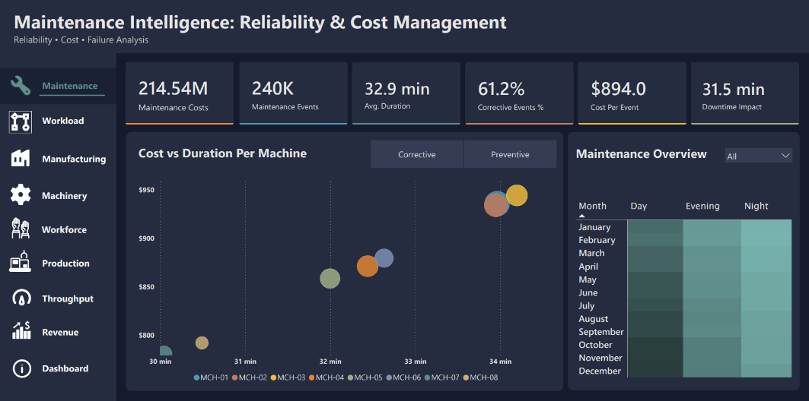
Fig1. Maintenance Report

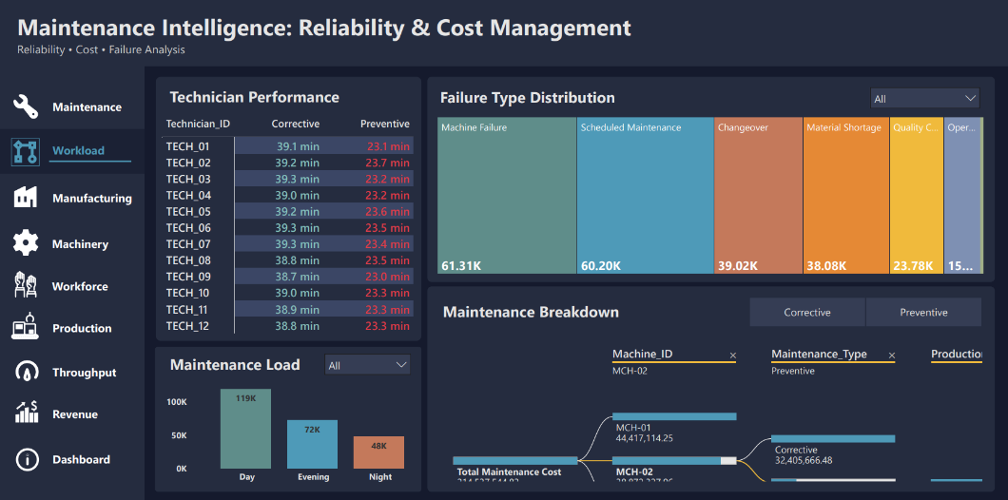
Fig2. Workload Report
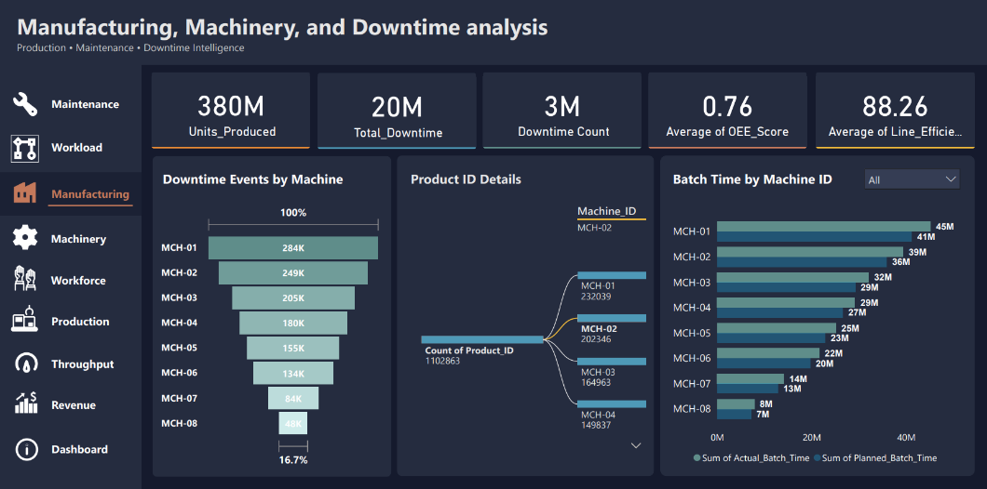
Fig3. Manufacturing Report
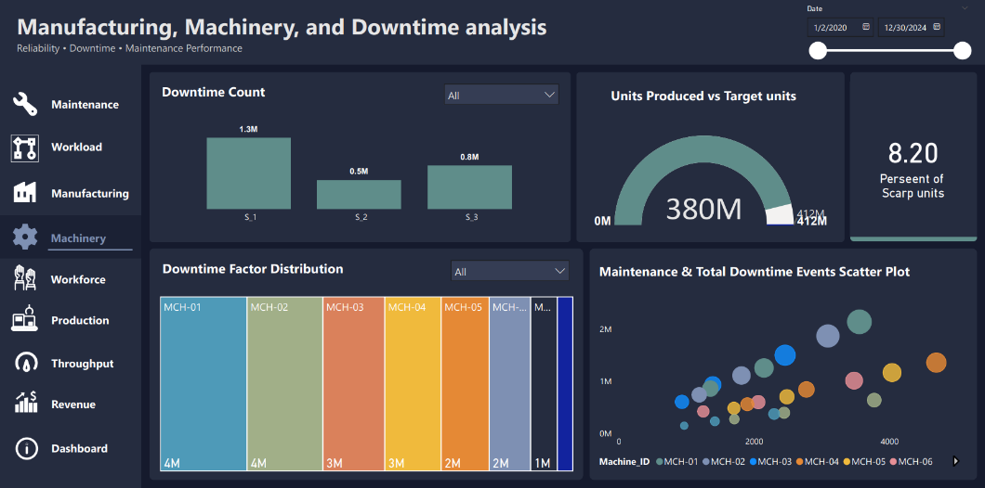
Fig4. Machinery Report
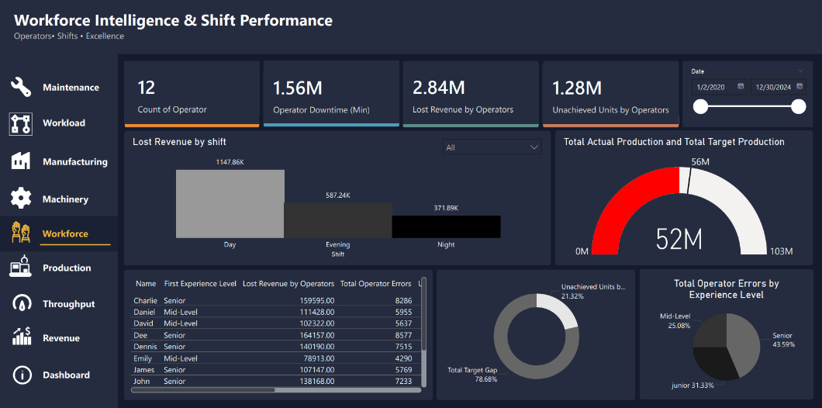
Fig5. Workforce Report
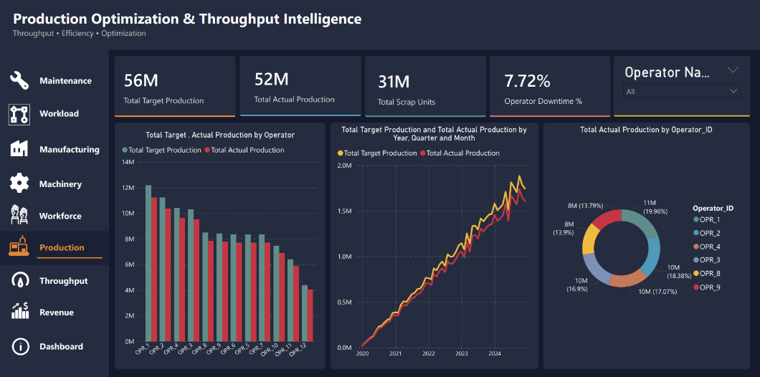
Fig6. Production Reports
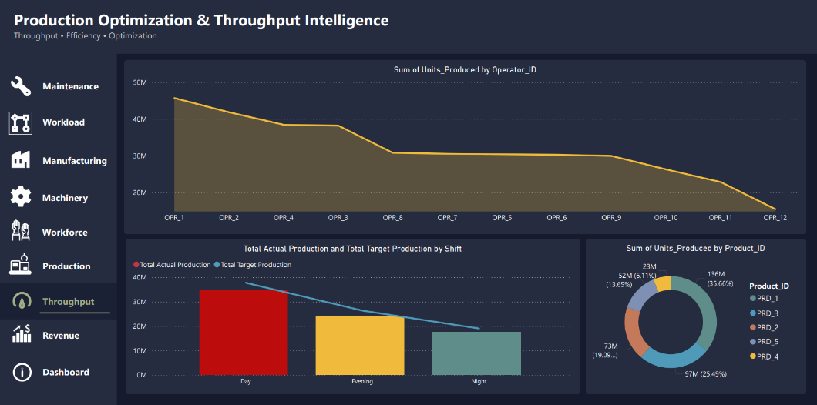
Fig7. Throughput Report
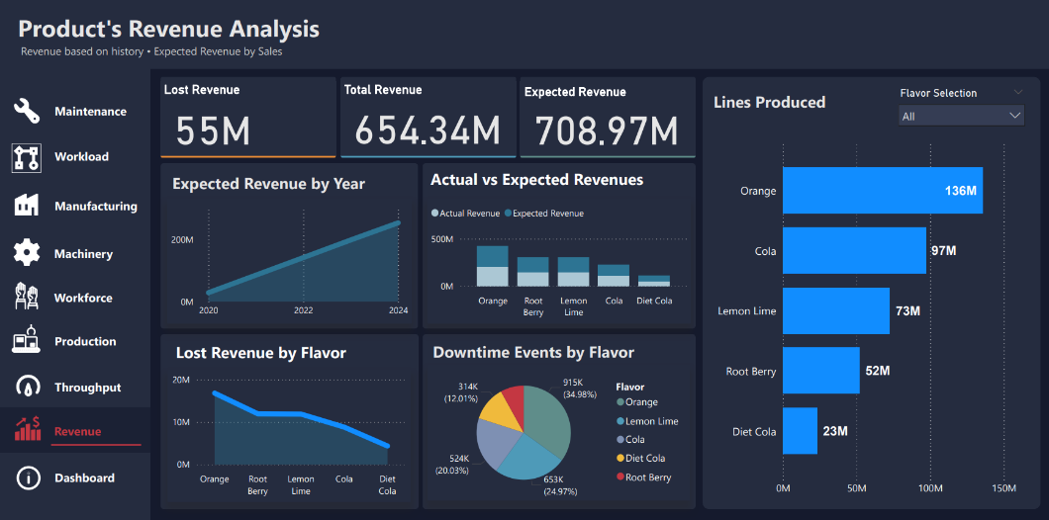
Fig8. Revenue Report
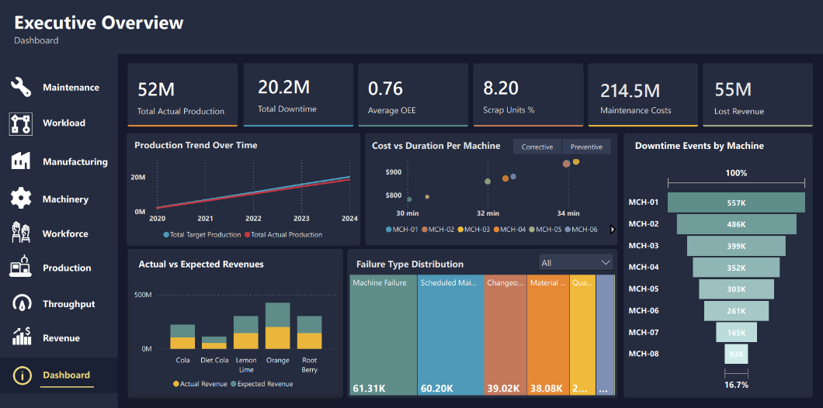
Fig9. Dashboard

11. Project Value & Impact
This project demonstrates a complete end-to-end data analytics pipeline, from raw data processing to executive-level decision support.

Key value contributions:
- Transform operational data into actionable insights
- Reduce production losses through root cause identification
- Supports both operational and strategic decision-making
- Improves efficiency and reduces costs

From a business perspective, the system enables organizations to shift from reactive problem-solving to proactive performance optimization, directly enhancing profitability and operational excellence.

